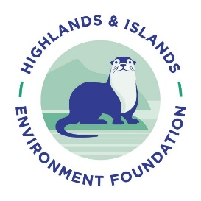
Expression of Interest
About this form
This form should be used to submit an expression of interest for funding from the Highlands & Islands Environment Foundation (HIEF). You must submit your expression of interest by 9am, Monday 22nd April 2024, using this form.

Please e-mail the completed version to sally@hief.scot, with the subject line ‘Expression of interest form’.

The form is made up of two sections and allows you to provide information about your organisation(s) & the project for which you are seeking funding.

Section 1 - requires some basic contact information so that we can get in touch with you about your expression of interest & is where you should provide information on your organisation, & any other partner organisations involved in the project.

Section 2 - in this section give a brief description of the project for which you are seeking funding.

Please do not exceed the word limits for each question

Please note applicants who successfully reach stage two will have the opportunity to refine the information included in their expression of interest, as part of their full application.

Section 1 – Contact information
Applicant contact name

Applicant contact e-mail

Applicant contact phone number

Please provide the name & address of the lead organisation & list any partner organisations which will deliver the project? Please provide registered company &/or charity numbers where applicable.

Please state the aims and objectives of your lead organisation? Please provide a mission statement where available. (max. 150 words)

Section 2 – Your project
Project title/name.

Project summary. Tell us about your project – what will it do? What environmental challenge will it address? Please include the planned approach to be taken, the logic behind this & anticipated results & outcomes. (max. 500 words)

Please explain how your project is led by &/or linked to the community? Community engagement can be with either a geographic or a community of interest. (max. 200 words)

Please state the amount of funding you wish to apply for including a breakdown of how this fits into the overall budget for your project. Please note HIEF grants range from £5,000 to £15,000.

