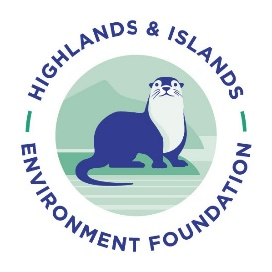Expression of Interest

About this form

This form should be used to submit an expression of interest for funding from the Highlands & Islands Environment Foundation (HIEF). You must submit your expression of interest by **9am, Monday 18th September 2023**, using this form.

Please e-mail the completed version to [sally@hief.scot](mailto:sally@hief.scot), with the subject line ‘*Expression of interest form’*.

The form is made up of three sections and allows you to provide information about your organisation(s) & the project for which you are seeking funding.

**Section 1** - requires some basic contact information so that we can get in touch with you about your expression of interest.

**Section 2** – is where you should provide information on your organisation, & any other partner organisations involved in the project.

**Section 3** - in this section give a brief description of the project for which you are seeking funding.

Please **do not** exceed the word limits for each question

*Please note* *applicants who successfully reach stage two will have the opportunity to refine the information included in their expression of interest, as part of their full application.*

# Section 1 – Contact information

**Applicant contact name**

**Applicant contact e-mail**

**Applicant contact phone number**

**Lead organisation address**

# Section 2 – Your organisation(s)

**Please provide the name of your lead organisation & any partner organisations?** *Please provide registered company &/or charity numbers where applicable.*

**Please state the aims and objectives of your lead organisation?** *Please provide a mission statement where available.* **(max. 150 words)**

# Section 3 – Your project

**Please explain the nature of the environmental challenge(s) your project seeks to address?***Please provide detail of how this challenge affects the areas reached by your project.* **(max. 200 words)**

**Please provide a summary of your project.** *Please include the planned approach to be taken, the logic behind this & anticipated results & outcomes.* **(max. 500 words)**

**Please explain how your project is led by &/or linked to the community?** *Community engagement can be either geographic or be a community of interest.* **(max. 200 words)**

**Please state the amount of funding you wish to apply for including a breakdown of how this fits into the overall budget for your project.**